Aytm x Neo Smart Living Joint Challenge
CPP AI Hackathon — “AI for a Better Future” Cal Poly Pomona | Artificial Intelligence Fair — April 16, 2026

Challenge Title
Open-Source Simulated Market Research: Building an Accessible Qual-to-Quant Pipeline
Field | Detail
Track Sponsors | Aytm + Neo Smart Living (joint)
Prize Pool | $2,000 “Aytm x Neo Smart Living Challenge Award”
Category | Industry Standards & Thought Leadership

Why This Challenge Matters

The Problem: Market Research Is Expensive, Unreliable for Niche Audiences, and Hard to Set Up
Traditional market research faces three compounding pain points:
- Higher costs for niche markets. A general-population 10 minutes survey (n=600) costs ~$6,000. The same study targeting SoCal homeowners — a niche audience relevant to Neo Smart Living’s Tahoe Mini — costs $12,000–$24,000 due to 1.5–3x per-complete premiums. Depth interviews add $3,000–$9,000. For small businesses, startups, and student researchers, this is prohibitive. It is an accessibility gap for those who need it most. Startups and new products require the most market research, yet face the highest cost barriers. This creates a dilemma: entrepreneurs with the greatest need have the least access, leading to preventable failures and unfulfilled potential.
- Unreliable synthetic results. LLM-generated “digital twins” offer a low-cost alternative (~$2–$4 for an entire simulated study), but they introduce well-documented distortions. Peng et al. (2026) identify five key ways digital twins act as “funhouse mirrors” — systematically misrepresenting real human preferences. Without validation workflows, synthetic data can mislead rather than inform.
- Difficulty setting up API workflows. Even when the tools exist, connecting LLM APIs to persona generation, interview simulation, survey response synthesis, and analysis dashboards requires programming expertise that most marketing researchers and students lack. There is no accessible, open-source pipeline that walks a practitioner from qualitative interviews through quantitative survey simulation.

The Opportunity: An Open-Source Ecosystem for Simulated Market Research
Recent research demonstrates both the promise and the limits of AI-augmented market research:
- Toubia et al. (2025) built Twin-2K-500, a dataset of digital twins for 2,000+ people based on 500+ survey questions, showing that LLMs can generate surprisingly coherent synthetic respondent profiles when grounded in rich persona data.
- Peng et al. (2026) stress-tested these digital twins and found five systematic distortions — establishing that synthetic data needs transparent validation, not blind trust.
- Arora, Chakraborty & Nishimura (2024) proposed AI-Human Hybrids for marketing research, demonstrating that LLMs work best as collaborators in the research process — augmenting human judgment at each stage rather than replacing it.
- Lin (under review) developed STAMP (Structured Taxonomy AI Measurement Protocol), a dual-LLM coding process that uses two independent LLMs to classify the same content and flags disagreements for human adjudication. This dual-LLM design is the methodological basis for why our prototype uses two models (GPT-4.1-mini + Gemini 2.5 Flash) throughout — cross-model agreement signals reliability, while divergence flags where synthetic outputs should not be trusted.
Together, these papers point to a clear gap: an open-source, educational ecosystem where students and practitioners can simulate the core market research workflow (qualitative interview → quantitative survey) and learn to critically evaluate the outputs.
This aligns with the NSF’s $400K to $1.5M Pathways to Enable Secure Open-Source Ecosystems (PESOSE, NSF 26-506) vision: building sustainable open-source tools that serve a broad community, with transparent documentation, modular architecture, and a focus on education and accessibility.

What Already Exists: The Prototype SOP
We have built a working prototype (see SOP: Simulated Interviews and Survey Responses) that demonstrates the end-to-end pipeline for one client case — Neo Smart Living’s Tahoe Mini:
Phase 1 — Simulated Qualitative Interviews: - 30 simulated depth interviews across two LLMs (GPT-4.1-mini + Gemini 2.5 Flash) - 8 semi-structured questions covering backyard relationship, unmet needs, lifestyle fantasy, product reaction, barriers, and discovery channels - Three-layer analysis: VADER sentiment, LDA thematic analysis (k=6), and LLM-based emotional tone classification (8-emotion taxonomy) - 6-tab Streamlit dashboard: Overview, Sentiment, Emotional Tone, Thematic Analysis, Segment Discovery, Full Transcripts
Screenshot — Thematic Analysis tab (from prototype qualitative dashboard):
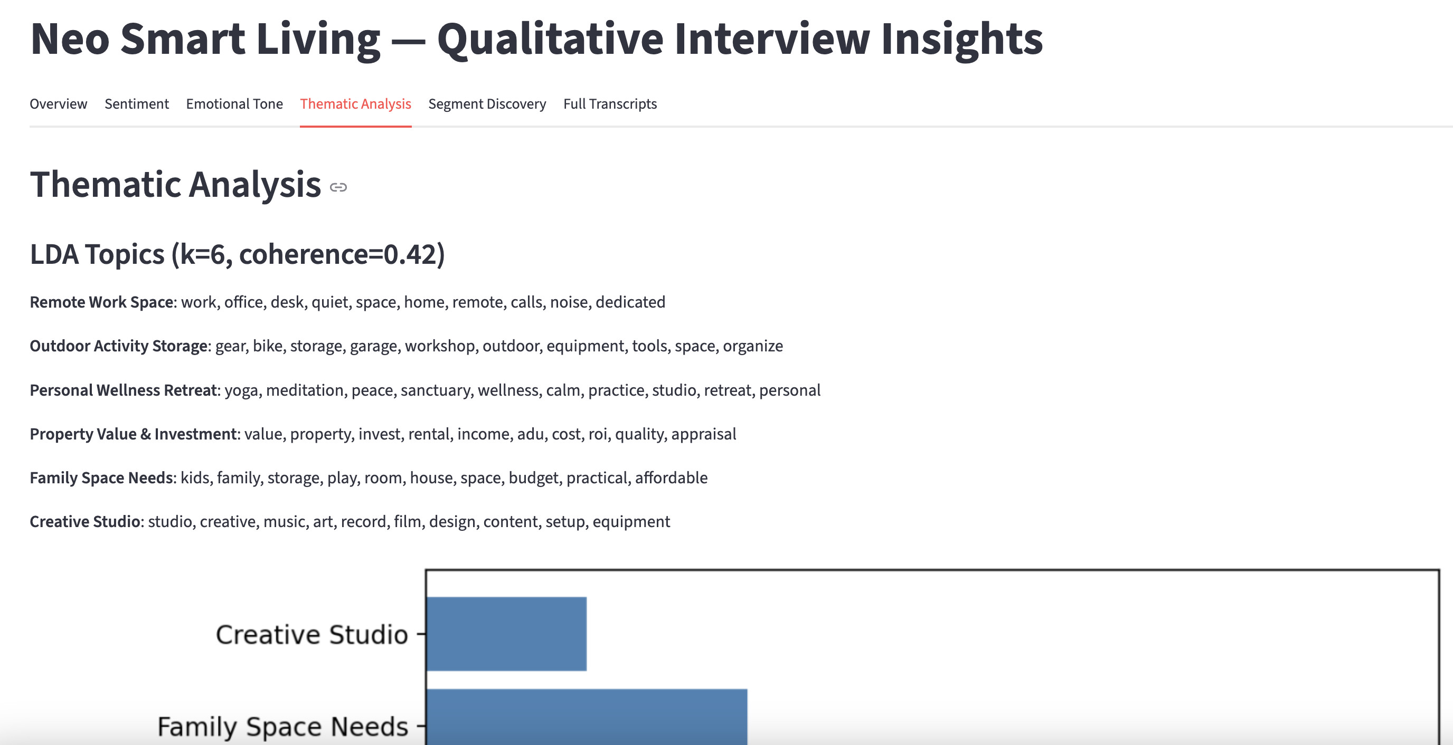
Thematic Analysis
LDA discovers 6 topics: Remote Work Space, Outdoor Activity Storage, Personal Wellness Retreat, Property Value & Investment, Family Space Needs, and Creative Studio — each with keyword lists. These emergent themes inform survey design and segment definitions.
Screenshot — Full Transcripts tab (from prototype qualitative dashboard):
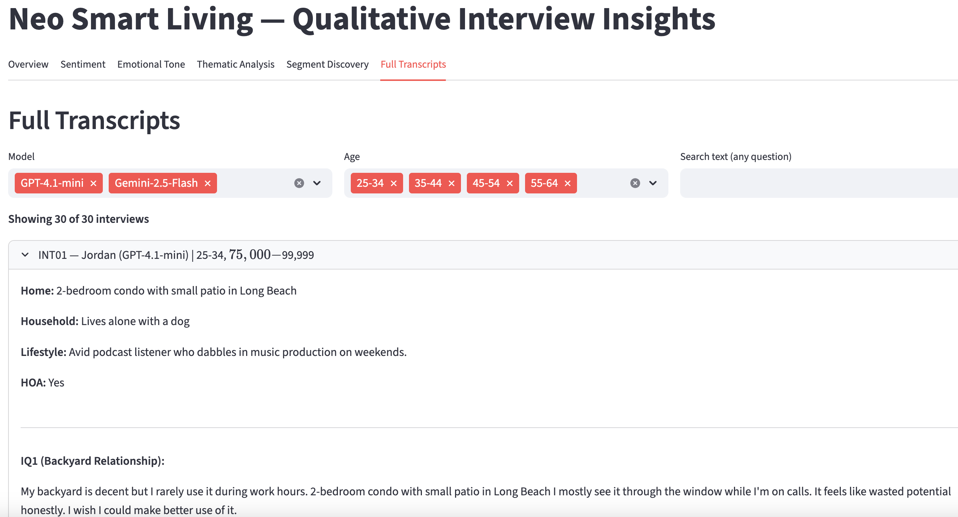
Full Transcripts
Searchable, filterable interview transcripts with persona metadata (model, age, income, home type, lifestyle). Each of the 30 synthetic interviewees responds to all 8 interview questions in naturalistic, persona-grounded language.
Phase 2 — Simulated Quantitative Survey: - 60 simulated survey responses (5 segments x 2 models x 6 respondents each) - ~35 survey items covering purchase interest, intended use, barriers, positioning concepts, value drivers, sponsorship, and demographics (see Neo Smart Living — Survey_HighMedPriority.md) - Cross-model reliability checks (Mann-Whitney U) to flag where the two LLMs diverge significantly - 6-tab Streamlit dashboard: Overview, Purchase Interest, Use Case & Barriers, Concept Test, Value Drivers & Sponsorship, Model Comparison
Screenshot — Concept Test tab (from prototype quantitative dashboard):
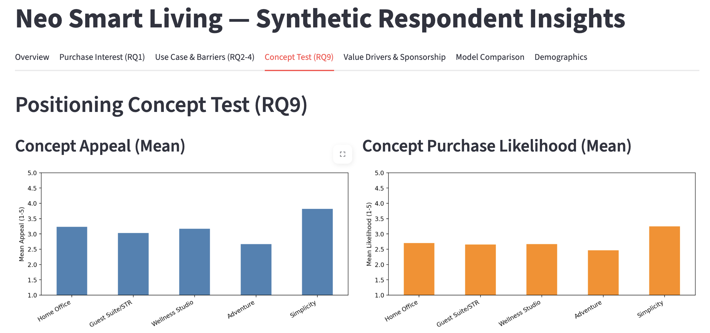
Positioning Concept Test
Positioning Concept Test (RQ9): Mean concept appeal and purchase likelihood across five positioning concepts (Home Office, Guest Suite/STR, Wellness Studio, Adventure, Simplicity). The Adventure concept shows the highest appeal among synthetic respondents, while purchase likelihood patterns reveal where messaging resonates vs. falls flat.
Screenshot — Demographics tab (from prototype quantitative dashboard):
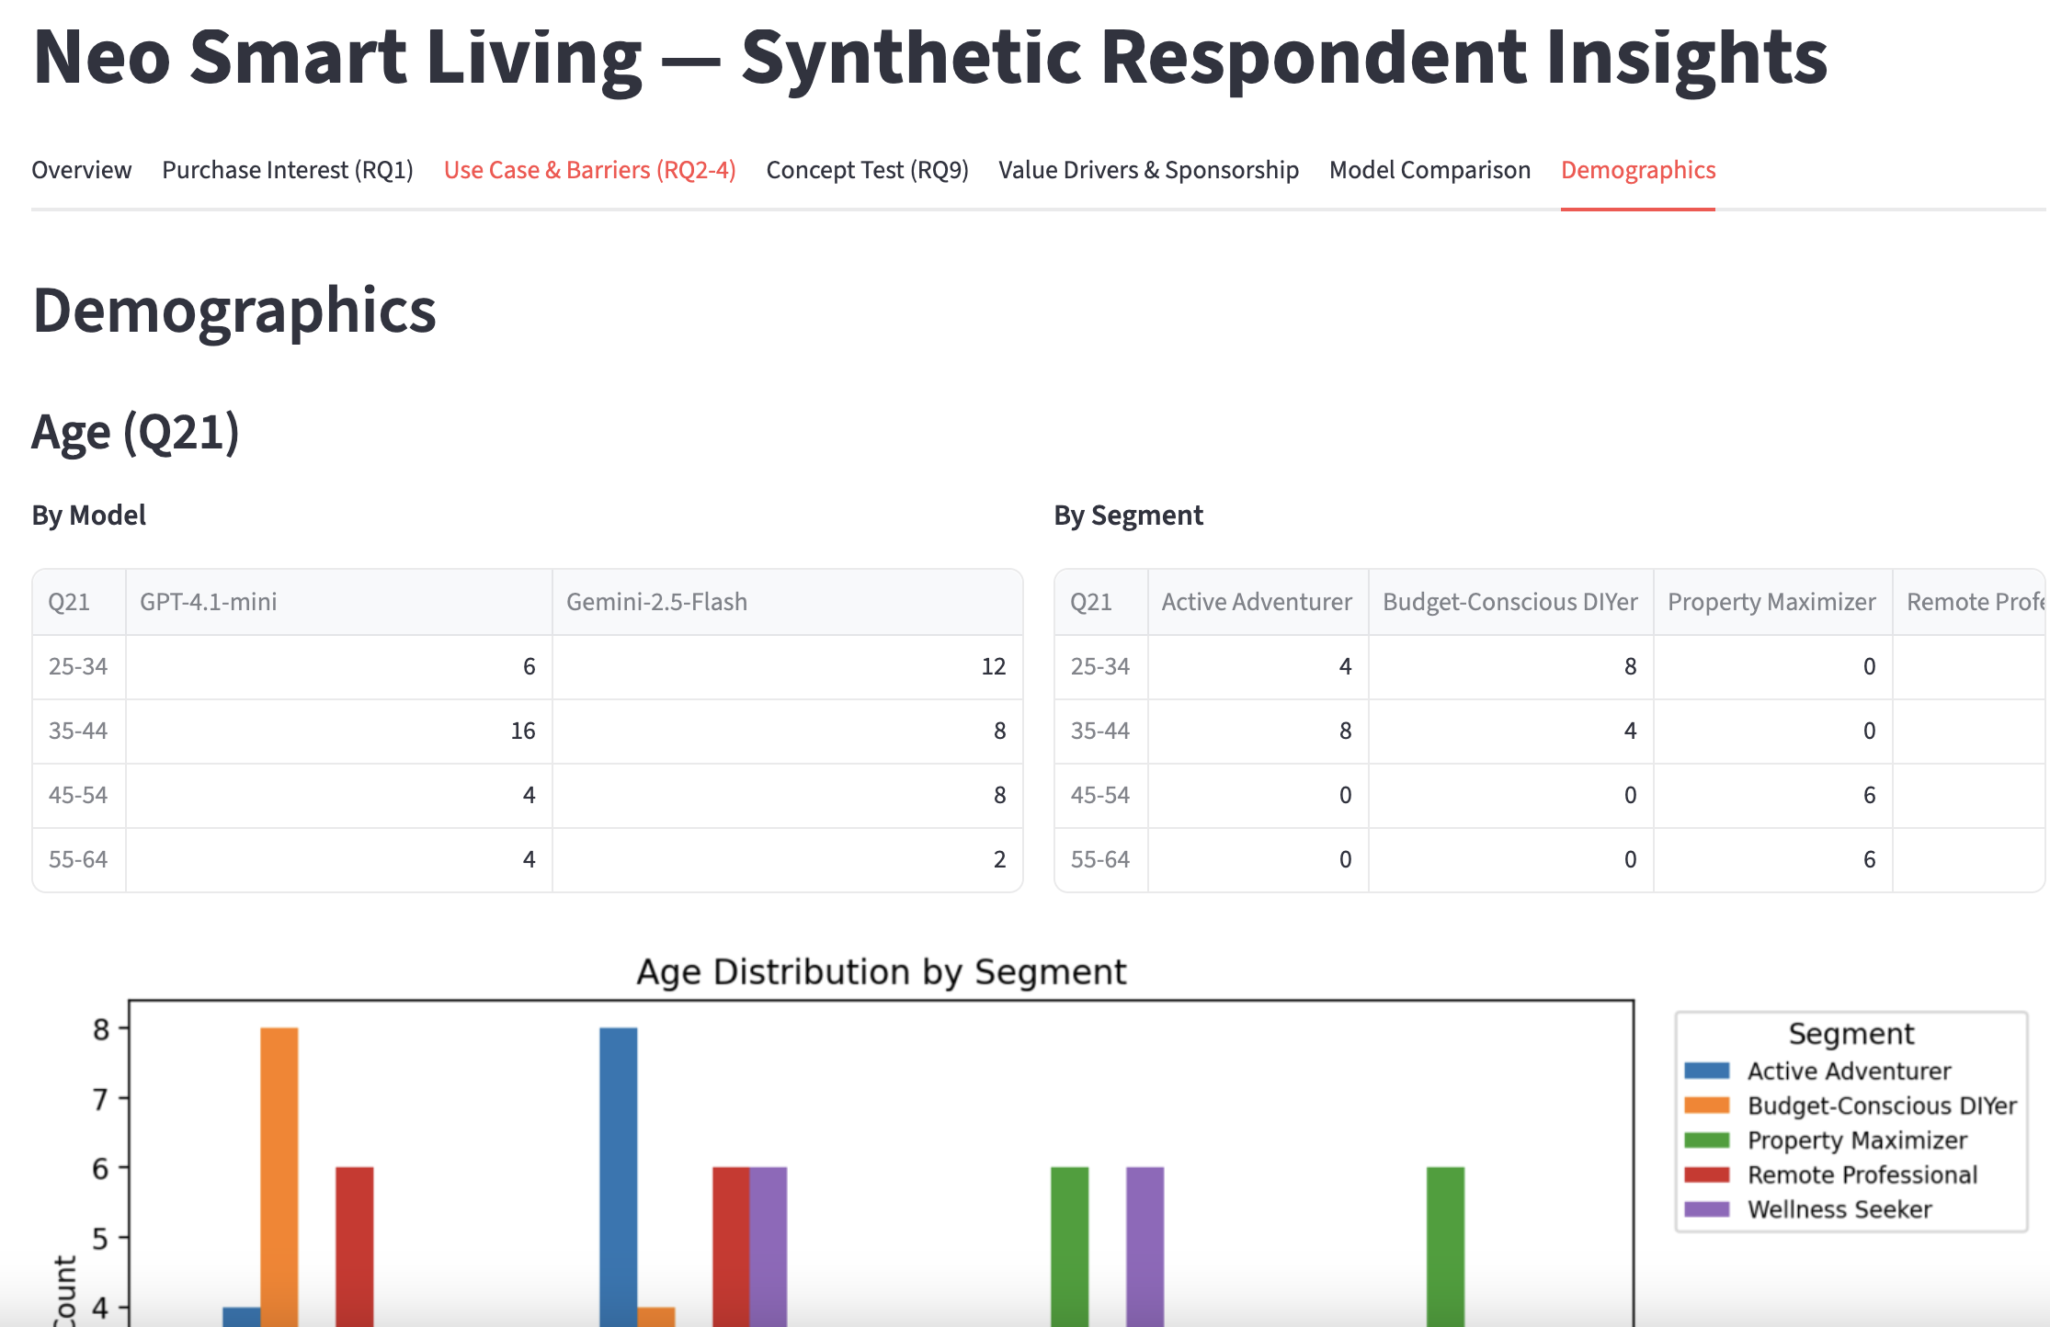
Demographics
Demographics breakdown by model (GPT-4.1-mini vs. Gemini 2.5 Flash) and by segment (Active Adventurer, Budget-Conscious DIYer, Property Maximizer, Remote Professional, Wellness Seeker). Age distribution by segment shows how synthetic personas map to different demographic profiles — a key input for real sampling plan design.
This prototype works, but it is a single-case proof of concept. The challenge asks participants to improve, extend, and package it into a reusable open-source tool.

Problem Statement
Build toward an open-source simulated market research ecosystem that enables students and practitioners to:
- Simulate qualitative interviews — Generate persona-grounded depth interviews with LLMs and analyze them for sentiment, themes, and emergent segments
- Simulate quantitative survey responses — Produce synthetic survey data from segment-based personas and validate outputs with cross-model reliability checks (following the dual-LLM principle from STAMP)
The Neo Smart Living Tahoe Mini case serves as the live demonstration. The sample survey (Neo Smart Living — Survey_HighMedPriority.md) and prototype SOP provide the starting point.
Participants can focus on one or more challenge stages — you do not need to build the entire pipeline. Deep work on a single stage is valued equally to breadth.

Challenge Stages
The simulated market research pipeline has six stages. Each represents an independent contribution opportunity.

Stage 1: Client Discovery Interview
What it is: Before any research begins, you need to understand the client’s business. In this stage, a customized LLM role-plays as a digital twin of the client — configured with the founder’s background, product specs, business context, and growth strategy — so that a researcher can practice discovery questions and receive contextually grounded responses.
Baseline prototype: The Customized GPT for Learning Business Case document (Example 1.5) provides an instruction template for configuring an LLM as Neo Smart Living CEO Tony Koo. The instruction sets his persona so students can ask discovery questions (product/service, value proposition, competitive landscape, customer types, priorities, decisions) and receive realistic responses.
What participants can improve: - Fidelity of the digital twin instruction (more detailed persona grounding) - Realism of client responses (handling follow-up questions, expressing uncertainty naturally) - Framework for comparing simulated vs. real client answers - Generalizing the instruction template so it works for any client, not just Tony Koo

Stage 2: Simulated Consumer Interviews
What it is: The same approach as Stage 1, but now the LLM role-plays as potential customers rather than the client. Diverse consumer personas (SoCal homeowners with varying demographics, lifestyles, and housing situations) are interviewed to surface unmet needs, emotional reactions, and language patterns — the qualitative foundation for survey design.
Baseline prototype (from SOP): - interview_personas.py — 30 persona definitions with demographic and psychographic details - synthetic_interviews.py — Generates 30 depth interviews (15 per LLM) using 8 semi-structured questions - interview_analysis.py — Three-layer analysis: VADER sentiment (no API), LDA thematic (1 API call), emotional tone classification (30 API calls, 8-emotion taxonomy) - interview_dashboard.py — 6-tab Streamlit dashboard for exploring results
Interview guide (8 questions):
ID | Topic | Question
IQ1 | Backyard relationship | Tell me about your backyard. How do you use it? How do you feel about it?
IQ2 | Unmet home needs | What are the biggest unmet needs in your home?
IQ3 | Prior consideration | Have you ever thought about adding a separate structure?
IQ4 | Lifestyle fantasy | If you could add a ~120 sq ft private backyard space tomorrow, what would you use it for?
IQ5 | Work-life boundaries | How do you handle work/personal boundaries at home?
IQ6 | Product reaction | [Tahoe Mini description at $23K, one-day install, permit-light]. What’s your immediate reaction?
IQ7 | Barriers & drivers | What would need to be true for you to seriously consider this? What’s the dealbreaker?
IQ8 | Social & discovery | Would brand sponsorship affect your perception? How do you discover home products?
What participants can improve: - Persona diversity and realism (expand beyond 30; add ethnic/cultural dimensions) - Multi-turn probe logic (follow-up questions based on initial answers) - Segment discovery validation (cluster analysis on interview features vs. name-matching) - The qual-to-quant handoff: feeding interview-discovered themes into survey design and segment definitions
Simple demo idea: Take 3–5 personas, run simulated interviews, and show how themes emerge differently across persona types.

Stage 3: AI-Assisted Survey Design
What it is: Translate qualitative findings into a structured survey instrument. This stage bridges the interview insights (Stage 2) into a quantitative questionnaire with screener questions, Likert scales, concept tests, and demographics.
Benchmark — Aytm Skipper: Aytm’s AI-powered survey creation platform (aytm.com/skipper) offers AI-assisted drafting (Draft), audience exploration (Explore), open-end coding (Autocode), and conversational survey AI (Conversation AI). The goal is not to compete with Skipper — it is to stress-test and improve the open-source alternative by comparison:
Dimension | Skipper (Commercial) | Open-Source Goal
Transparency | Black-box AI suggestions | Visible, modifiable prompts and logic
Provider lock-in | Aytm platform | Works with any LLM API
Cost | Subscription-based | Free for educational use
Customization | Limited to platform options | Fully extensible by users
Sample instrument: The Neo Smart Living — Survey_HighMedPriority.md provides a complete ~35-item survey covering screening, category baseline, product stimulus, purchase interest, intended use, barriers, positioning concept tests, value drivers, adventure sponsorship, demographics, and attention checks.
What participants can improve: - AI-assisted question generation from interview themes - Response scale selection and skip logic suggestions - Survey pretest simulation (synthetic respondents flag confusing or redundant questions) - Side-by-side comparison with Skipper’s outputs on the same brief

Stage 4: Simulated Survey Respondents
What it is: Generate synthetic survey responses from segment-based personas. Each simulated respondent completes the full survey instrument, producing structured quantitative data for analysis. The dual-LLM design (from STAMP) serves as a built-in reliability check.
Baseline prototype (from SOP): - segments.py — 5 market segment definitions with demographic ranges and psychographic narratives - synthetic_respondents.py — Generates 60 responses (5 segments x 2 LLMs x 6 respondents each) - Validation: Likert clamped 1–5, demographics forced to match persona, attention check enforced - Cross-model reliability: Mann-Whitney U test flags variables where GPT-4.1-mini and Gemini 2.5 Flash diverge (p < 0.05 = low confidence)
What participants can improve: - Segment definitions informed by Stage 2 interview findings (closing the qual-quant loop) - Persona grounding detail (richer backstories produce more realistic responses) - Response consistency measurement (run 3x per persona, compute intra-persona Krippendorff’s alpha) - Sample size scaling (60 → 200+ respondents; cost tracking in tokens per respondent)

Stage 5: Data Analysis
What it is: Analyze the simulated survey data to answer research questions. Three types of analysis apply:
Descriptive analysis — Frequency distributions, means, and cross-tabs for all survey sections (purchase interest, intended use, barriers, concept test, value drivers, demographics).
Difference / segment comparison — Compare responses across market segments, demographic groups, and LLM models. Key research questions from the sample survey: - Remote vs. non-remote worker differences in purchase interest (RQ5) - Income x purchase willingness (RQ6) - Age differences in intended use (RQ7) - Outdoor recreation frequency x purchase interest (RQ8) - Concept preference x outdoor club membership (RQ11) - Adventure concept appeal x outdoor activity level (RQ12)
Association analysis — Explore relationships between variables (e.g., barrier severity x purchase likelihood, concept appeal x demographics, sponsorship impact x outdoor engagement).
Baseline prototype (from SOP): - 6-tab Streamlit quantitative dashboard: Overview, Purchase Interest, Use Case & Barriers, Concept Test, Value Drivers & Sponsorship, Model Comparison - Cross-model divergence flagging: where the two LLMs agree (high confidence) vs. diverge (needs real validation)
What participants can improve: - Statistical rigor (confidence intervals, effect sizes — not just p-values) - Visualization quality and clarity - Cross-model divergence interpretation (which findings are robust vs. model-dependent) - Confidence calibration: what can we trust from synthetic data vs. what needs real validation

Stage 6: Insights Presentation & Dashboard
What it is: Synthesize findings into a presentation outline organized around key insights from the simulated research.
Suggested structure: 1. The problem — Why simulated market research matters (cost, speed, accessibility) 2. The method — How the qual-to-quant pipeline works (interview simulation → survey simulation → analysis) 3. Key findings — Top 3–5 actionable insights for Neo Smart Living (e.g., which positioning concept wins, what barriers matter most, which segments show highest purchase intent) 4. Confidence assessment — Where do the two LLMs agree (high confidence) vs. diverge (needs real validation)? 5. Recommendations — What should Neo Smart Living do next with real research, informed by these simulated findings? 6. Open-source vision — How this pipeline could be packaged for broader use
What participants can improve: - Narrative structure and visualization design - Honest confidence calibration for a real business audience - Actionable framing (what would Tony Koo do with this?)

What Participants Deliver
Participants may focus on one or more stages. Deliverables scale accordingly:
Scope | Expected Output
Single stage deep-dive | Working code or prototype for that stage + a short write-up explaining the approach, what was improved, and what the limitations are
Multi-stage pipeline | Connected workflow across 2+ stages + analysis outputs + brief presentation outline
Full pipeline | End-to-end qual-to-quant demo + Neo Smart Living insights + open-source packaging recommendations
All deliverables must include:
- Working code or prototype — Runnable Python scripts, Jupyter notebooks, or Streamlit apps
- Responsible AI note (half page) — Synthetic data transparency, limitations acknowledgment, and when real research is required
- GenAI documentation — Tools used, prompts employed, AI-generated components, human modifications

Judging Criteria (50 points)
# | Criterion | Points | What Judges Look For
1 | Innovation & Problem Framing | 10 | How clearly does the team define the market research accessibility problem? How original and thoughtful is the AI-enabled pipeline design — does it go beyond a basic API wrapper to address the real challenges of synthetic data quality, cross-model validation, and the qual-to-quant handoff?
2 | Impact & Relevance | 10 | Does the solution address a real-world need with meaningful potential impact? Are the findings specific and actionable enough that Tony Koo could use them to inform a real marketing decision about the Tahoe Mini? Does the open-source pipeline have reuse potential — could another student or practitioner pick it up and run it for a different client?
3 | Technical or Design Feasibility | 10 | Is the pipeline credible and feasible? Code works, stages connect, API calls are efficient, outputs are validated, and cross-model reliability checks are implemented. Research methodology is sound: interview guides probe meaningfully, survey items map to research questions, analysis choices are appropriate — synthetic does not mean sloppy. Responsible AI: synthetic data is clearly labeled, limitations are honestly stated, the team distinguishes hypothesis generation from decision-grade evidence.
4 | User Need & Adoption Potential | 10 | Does the team show evidence that the simulated research pipeline produces insights users would trust and act on? Is there a plausible path to adoption — by students learning marketing research, by practitioners prototyping before committing real research budget, or by small businesses like Neo Smart Living that cannot afford $12K–$48K field studies? Is the code modular, documented, and adaptable?
5 | Storytelling | 10 | Is the solution clearly and compellingly communicated, with a coherent narrative and professional 5-minute video? Does the team make the “why” vivid — connecting the open-source vision to the cost barrier, the Neo Smart Living case, and the confidence calibration question (what can we trust vs. what needs real validation)?

Data & Supporting Files
All files listed below are included in this challenge folder.

Working Prototype Code (prototype/)
A complete, runnable Python codebase that demonstrates the end-to-end pipeline for the Neo Smart Living case. Start here if you’re a technical participant. See prototype/README.md for setup instructions and a glossary of marketing research concepts.
File | What It Does | API Calls
Phase 1 — Interviews
interview_personas.py | 30 SoCal homeowner personas with demographics | 0
synthetic_interviews.py | Generates depth interviews via 2 LLMs (GPT-4.1-mini + Gemini 2.5 Flash) | 30
interview_analysis.py | Sentiment (VADER) + topic modeling (LDA) + emotional tone (LLM) | 31
interview_dashboard.py | Streamlit qualitative dashboard (6 tabs) | 0
generate_test_interviews.py | Offline test data — no API key needed | 0
Phase 2 — Survey
segments.py | 5 market segment definitions with psychographic narratives | 0
synthetic_respondents.py | Generates 60 survey responses via 2 LLMs | 60
analytics.py | Shared stats module (descriptive stats, Mann-Whitney U, effect sizes) | 0
report.py | Static report generator (4 CSVs + 5 charts) | 0
dashboard.py | Streamlit quantitative dashboard (7 tabs with sidebar filters) | 0
generate_test_data.py | Offline test data — no API key needed | 0
Quick start (no API key): pip install -r prototype/requirements.txt && streamlit run prototype/dashboard.py — sample output data is included so dashboards work immediately.
Full run (~$0.05-$0.10 via OpenRouter): Set OPENROUTER_API_KEY env var or create prototype/.env, then run python prototype/synthetic_interviews.py and python prototype/synthetic_respondents.py.

Reference Documents
Material | File | Purpose
Prototype SOP | prototype/README.md | Full workflow, setup instructions, marketing concept glossary
Survey Instrument (Markdown) | prototype/Input/Neo Smart Living — Survey_HighMedPriority.md | ~35-item survey in machine-readable format (used by prototype code)
Survey Instrument (Google Forms PDF) | Neo Smart Living — Tahoe Mini Survey (High + Medium Priority) - Google Forms.pdf | Final formatted survey as participants would see it
Customized GPT Guide | Customized_GPT_for_Learning_Business_Case.pdf | Digital twin of Tony Koo instruction (Stage 1 reference)
Neo Smart Living Background | Neo Smart Living Background.pdf | Client brief for the Tahoe Mini
STAMP Paper | STAMP_JM_proof.pdf | Dual-LLM methodology reference (why we use two models)
Aytm Skipper (benchmark) | https://aytm.com/skipper/ | Commercial AI survey platform for Stage 3 comparison

Dashboard Screenshots (from prototype output)
Screenshot | File
Qualitative — Thematic Analysis tab | qualitative interview insights_theme analysis.png
Qualitative — Full Transcripts tab | qualitative interview insights_full transcript.png
Quantitative — Concept Test tab | quantiative_survey_positining concept.png
Quantitative — Demographics tab | quantiative_survey_demographics.png

Cost Comparison: Why Open-Source Matters
Item | Simulated (This Pipeline) | Real (Field Research)
30 depth interviews | ~$0.50 (API calls) | $3,000–$9,000
600 survey responses (SoCal homeowners) | ~$1.50 (API calls) | $12,000–$24,000
Platform/hosting fees | $0 (local Streamlit) | $500–$2,000
Programming and PM | $0 (open-source) | $1,000–$5,000
Analysis | ~$0.50 (LLM analysis) | $2,000–$10,000
Total | ~$2–$4 | $6,000–$48,000+
The simulated approach produces directional hypotheses — not reliable data for business-critical decisions. Its value is in informing real survey design, prioritizing questions, and generating testable hypotheses before committing real research budget.

Appendix A: Sponsor Backgrounds

Aytm — Insights Technology Platform
Aytm (ask your target market) is an insights technology (intech) company that provides an end-to-end consumer research platform — from audience targeting and survey design to AI-powered analysis.
Origin story: Co-founders Lev Mazin and David Handel built several applications that never gained traction. Rather than giving up, they asked why — and discovered that quality market research was prohibitively expensive for entrepreneurs and students. They launched aytm’s minimum viable product in three months (the same time it would have taken to run a single full-service survey) and debuted at TechCrunch50, where the model was called “revolutionary” in an industry dominated by expensive incumbents.
Platform capabilities:
Product | What It Does
Skipper AI — Draft | AI-assisted survey creation and question generation
Skipper AI — Explore | Audience targeting and segmentation
Skipper AI — Autocode | Automated open-end response coding
Conversation AI | Qualitative interviews at scale via AI-moderated conversations
PaidViewpoint | Proprietary consumer panel community
Insights Dashboard | Real-time results visualization and analysis
Industries served: Agency, Automotive, Banking & Finance, Consumer Brands, Entertainment, Healthcare & Wellness, Retail, Telecom.
Education commitment: Aytm is building Lighthouse Academy (aytm.com/lighthouse) to bring its Skipper AI tools into university classrooms. The MSU and UGA master of marketing research program partnership demonstrates a $1M+ commitment to training the next generation of researchers. The newly launched Harbor community connects insights professionals and students.
Core values: Abundance mindset, Empathy, Creativity, Curiosity, Organic growth.
Relevance to this challenge: Aytm’s Skipper platform serves as the commercial benchmark for the open-source pipeline students will build. Students can compare their transparent, modifiable approach against Skipper’s capabilities — not to compete, but to stress-test and improve the open-source alternative.
aytm.com | Inc. 5000 America’s Fastest-Growing Private Companies

Neo Smart Living — Prefab Homes for Adventurers and Forward-Thinkers
Neo Smart Living is a prefab home company founded by a group of adventure seekers and future thinkers who believe that home ownership should be accessible for all. With broad experience in recreational properties and vehicles, they make dream homes, getaways, and income properties attainable realities.
The problem Neo Smart Living solves: The traditional home building process is shaped by lack of information, hidden fees, delays, and frustration. The average cost to construct a stick-built home is $200–$500 per square foot (not including changing lead times or material escalation). Neo Smart Living uses cutting-edge technology, superior craftsmanship, and environmental responsibility to streamline every aspect of home building without compromising quality or comfort.
Flagship product — Tahoe Mini: - ~117 sq ft prefab backyard structure - ~$23,000 price point - One-day installation; often permit-free in California - Seven-figure revenue achieved in 2025 - Use cases: home office, guest suite, short-term rental, wellness studio, adventure basecamp
Eco-conscious construction: Building and construction accounts for 39% of all carbon emissions globally, and 40% of construction materials typically end up in landfills. Because Neo Smart Living units are manufactured in controlled factory environments, their prefab homes generate less waste and use less energy across their lifespan — while still allowing full customization.
Business model: Host. Play. Build income. Neo Smart Living positions its products at the intersection of lifestyle, investment, and sustainability — serving homeowners who want to add livable space without a traditional construction project.
Leadership:
- Ming — Co-Founder & CEO. Ming is an experienced entrepreneur with over a decade of leadership in the RV industry and a proven track record across multiple sectors including RV rental, manufacturing, and conversion. With more than eight years of specialized expertise, he has managed the production of high-end RVs in Los Angeles and founded a highly regarded RV customizing facility known for exceptional service and technical proficiency. Ming’s transition into the mobile home and prefab sectors has further showcased his ability to drive innovation and maintain high standards of quality assurance. His technical acumen and strategic insights have been pivotal in advancing Neo Smart Living’s operational excellence and growth. Ming also leads the company’s expansion through Neo Camper (neocamperusa.com), an overlanding RV series now manufacturing across facilities in Los Angeles, Australia, and Asia.
- Tony Koo — Co-Founder. Tony is a serial entrepreneur and adventurer based in Glendora, CA. He is a Cal Poly Pomona College of Business Administration dropout — a founder who left the classroom to build businesses, making this hackathon a full-circle moment connecting CPP students with a CPP-rooted entrepreneur. Tony’s entrepreneurial journey spans multiple ventures, and his hands-on, builder mentality drives Neo Smart Living’s product vision and community-first marketing approach. Tony serves as the live client for this challenge, and a customized GPT digital twin of Tony is available for student practice interviews (see Stage 1).
Growth context: Revenue growth has been largely referral and word-of-mouth. Neo Smart Living is now testing paid channels and community sponsorship strategies — particularly targeting outdoor adventure communities (mountain bikers, ATV clubs, outdoor yoga groups) through partnerships like IE-MTB (Inland Empire Mountain Bike Club).
Relevance to this challenge: Neo Smart Living is the live business case for the simulated market research pipeline. Student teams will generate qualitative and quantitative insights for the Tahoe Mini’s positioning — particularly the “Adventure Lifestyle / Community” concept (Concept 4) targeting outdoor enthusiasts. Findings should be specific enough that Tony Koo could use them to inform a real marketing decision.
Contact: Tony Koo (tony@neosmartliving.com) and Gabby Munoz, Executive Assistant (gabby@neosmartliving.com). For any communication with Tony, please also cc Gabby. You can schedule a tour at the Neo Smart Living facility through Gabby.
neosmartliving.com | 14762 Central Ave, Chino, CA 91710 | 1-888-NEO-0321

Appendix B: Academic References
- Toubia, O., Gui, G. Z., Peng, T., Merlau, D. J., Li, A., & Chen, H. (2025). Database Report: Twin-2K-500: A Data Set for Building Digital Twins of over 2,000 People Based on Their Answers to over 500 Questions. Marketing Science, 44(6), 1446–1455. https://doi.org/10.1287/mksc.2025.0262
- Peng, T., Gui, G., Brucks, M., et al. (2026). Digital Twins as Funhouse Mirrors: Five Key Distortions (arXiv:2509.19088). arXiv. https://doi.org/10.48550/arXiv.2509.19088
- Arora, N., Chakraborty, I., & Nishimura, Y. (2024). EXPRESS: AI-Human Hybrids for Marketing Research: Leveraging LLMs as Collaborators. Journal of Marketing. https://doi.org/10.1177/00222429241276529
- Lin, Y. F. (under review). STAMP: A Standardized Protocol and Web Application for LLM-based Text Classification. Journal of Marketing. [Introduces the dual-LLM coding process used as the methodological basis for cross-model reliability checks in this pipeline.]
- NSF 26-506. Pathways to Enable Secure Open-Source Ecosystems (PESOSE). U.S. National Science Foundation.

Appendix C: Instructor PA Mapping

For Instructors: Mapping to Marketing Research Course Assignments
The six challenge stages correspond to standard marketing research course assignments. Instructors adapting this challenge for coursework can use the following mapping:
Challenge Stage | Corresponding Course Assignment | Notes
Stage 1: Client Discovery Interview | PA2 (Project Client Choices) | The customized GPT digital twin of Tony Koo (see Customized GPT for Learning Business Case, Example 1.5) provides the instruction template
Stage 2: Simulated Consumer Interviews | PA3 (Define Marketing Problem & Research) | Uses the same LLM role-play approach as Stage 1, but for consumer personas; can serve as a simple simulated interview demo
Stage 3: AI-Assisted Survey Design | PA4 (Design a Questionnaire) | Reference Aytm Skipper as a commercial benchmark; the open-source version prioritizes transparency and extensibility
Stage 4: Simulated Survey Respondents | PA5 (Sampling Plan & Data Collection) | Synthetic respondents replace or supplement real data collection for prototyping
Stage 5: Data Analysis | PA6 & PA7 (Analysis Plan & Report) | Descriptive, difference (segment comparison), and association analyses on simulated data
Stage 6: Insights Presentation | PA8 (Term Project Presentation) | Presentation outline organized around key simulated insights

